ER Diagram for Problem 1:  
  
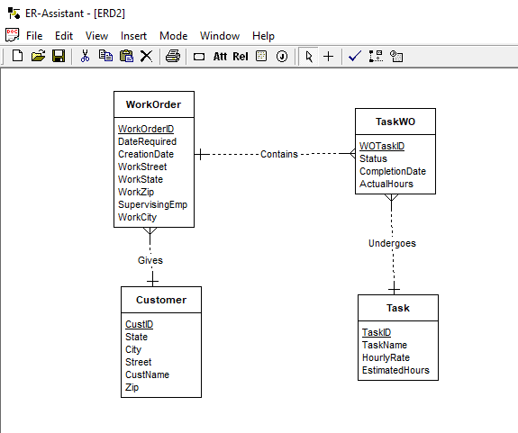

**ER Diagram based on New Revised Requirements:**

